 | 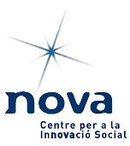 | 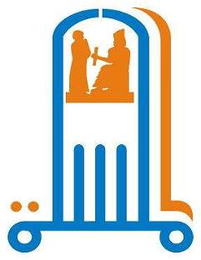 | With support of  

Almesalla Center with partnership with Un Ponte Per and
NOVA
And other Partners

The Joint project for Nonviolence

Workshop one
Nonviolent alternatives

Kurdistan–Erbil – IRAQ
16th – 20th Feb 2007

1-The general frame work
Following for the coordination and the cooperation between Almesalla Center in Iraq, Un Ponte Per (Italy), NOVA (Spain) and Centre Gandhi (Italy) for promoting nonviolence as an alternative in Iraq, with the fund and support of the Catalan agency
The workshop of 'Nonviolent Alternatives' had been held in Erbil – Kurdistan – Iraq for the period of 16th -20th of Feb 2007, 22 participants from all over Iraq discussed the conflict analysis and conflict resolution along with discussion of organizing nonviolence campaigns and peace building in Iraq
2- Objectives:
  - General objective
To improve the participants awareness about the nonviolence struggle as a alternative
  - Specific objectives

- To present mechanisms of conflict analyses
- To explain the main mechanisms of conflict managements
- To distinguish the concept of Nonviolence
- To Strategically plan for nonviolence campaign
- To define Iraqi Experiences in ( peace building, nonviolent Campaigns ) and taking out lessons learned
- To present the idea of LAONF web site
- TO Plan for the next nonviolence week in Iraq

3- Participants:

22 participants were selected from a group of applicants filled a form which includes information about the applicants, the type of their organizations, and their motivations to participates in this workshop.
The selection was done according to the following criteria
- The geographical distribution
- Representing various ethnical and political Iraqi parties
- Gender balance
- The applicants' previous activities
- Willingness ( ngo or individual ) to work for the promotion of nonviolence in the field
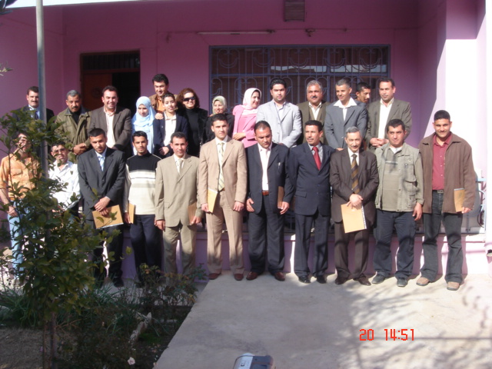

3.1 Gender distribution

Male | Female
18 | 4 | No.
82% | 18%

This table shows a low number of participated women due to the bad security situation in rest of Iraq, in addition to the difficulties of transportation and the sensitivity of the workshop topic

3.2 Geographical distribution

No of participants | City | Area | Gender | No
3 | Basrah | South Iraq | Males | 1
1 | Diwania | South Iraq | Female | 2
1 | Kut | Med Iraq | Male | 3
2 | Najaf | Med Iraq | Male and female | 4
9 | Baghdad | Baghdad | 2 Females, 7 Males | 5
1 | Erbil | Kurdistan | Male | 6
1 | Sulaimania | Kurdistan | Male | 7
3 | Faluja | West and Northwest Iraq | Males | 8
1 | Kirkuk | West and Northwest Iraq | Male | 9
22 | 9 | 5 |  | Total
This table shows the participants' geographical distribution in Iraq; and displays the cities where these NGOs operate.
The distinctive opportunity of the participating NGOs from different geographical areas has enriched the workshop by facilitating building a local group which can work for the workshop objectives and able to represent the Iraqi civil society.
The number of representatives from Baghdad shows that there was a special attention to the capital due to the high number of NGO’s and the level of violence there.

4- Training content:

4.1. Reception:
A social event took place in the 16th.February as one of Erbil's restaurant. All the participants and organizers met at this dinner.
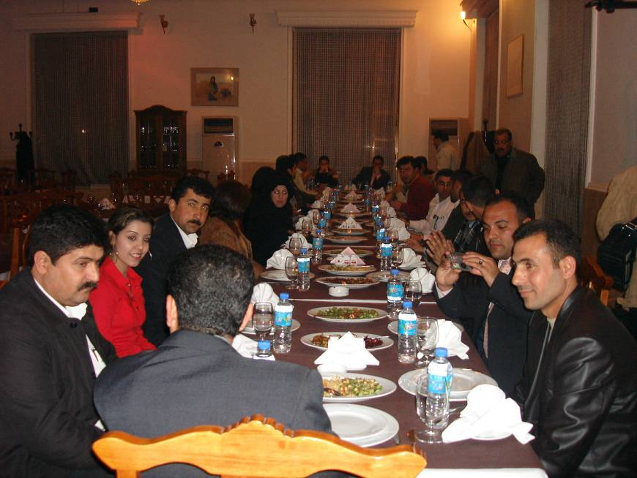

4.2: Opening Session:

Ismaeel Dawood, the program manager in UPP, welcomed the participants and presented the joint work of UPP and NOVA in promoting nonviolence in Iraq and presented the UPP, NOVA and Centro Gandhi wishes to this workshop of success, and their interest to support this initiative and others which promote for using alternative tools of peaceful social change, at the same time, apologized for the absence of some representatives due to emergence reasons. In addition, Al-Mesalla/ Erbil has welcomed the participants and presented the purpose of launching Erbil branch and the uses of Hiwar hall.

4.3: Participants' expectations and Program presenting session:

Ismaeel dawood facilitated this session through a simple game to break the ice between the participants. The game is called ''Trust Game''. The idea is divide the participants into some random groups; while in each group there's one person of covered eyes who should move from one point to another without falling down. The participants, accordingly, will help this person to move and get to know each others.

Concerning their expectations, the outcome was as the following:

- condemning violence
- working for national reconciliation
- acquiring experiences of non-violence work
- framing the main future work for building peace in Iraq
- conflict resolution
- being exposed to other international experiences concerning non-violence

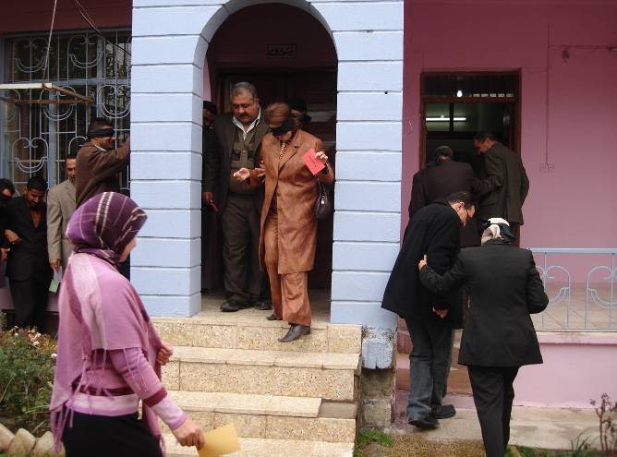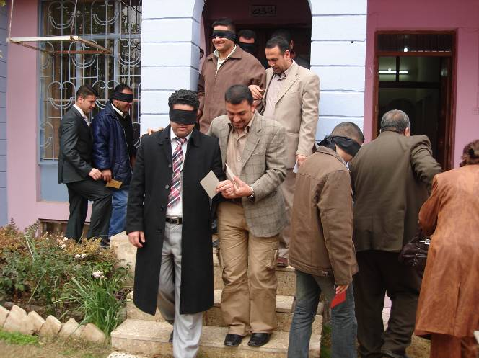

4-4: Training sessions:

4.4.1: Conflict analysis and methods of conflict management:

The NPA facilitated and trained on this issue. The used methodology was through presentations, open discussion and working groups. The session main purpose was to study the conflict justification with a focus on differences and clash in interests. Furthermore, the session intended to present the types of conflict, reason of analyzing the conflict, the axes of conflict and violence, and in addition, the necessity of implementing the techniques of understanding the conflict parties. At the same time, the trainer introduced the mechanisms of dealing with conflicts such as Arbitration, Mediation, Negotiation, settling the conflict with/ without dealing with the mean reasons of it. The working groups tried to frame the main parties in the Iraqi conflict, the participants discussed openly the main local/ regional parties and the American occupation, drawing a matrix of the conflict and the conflict parties.

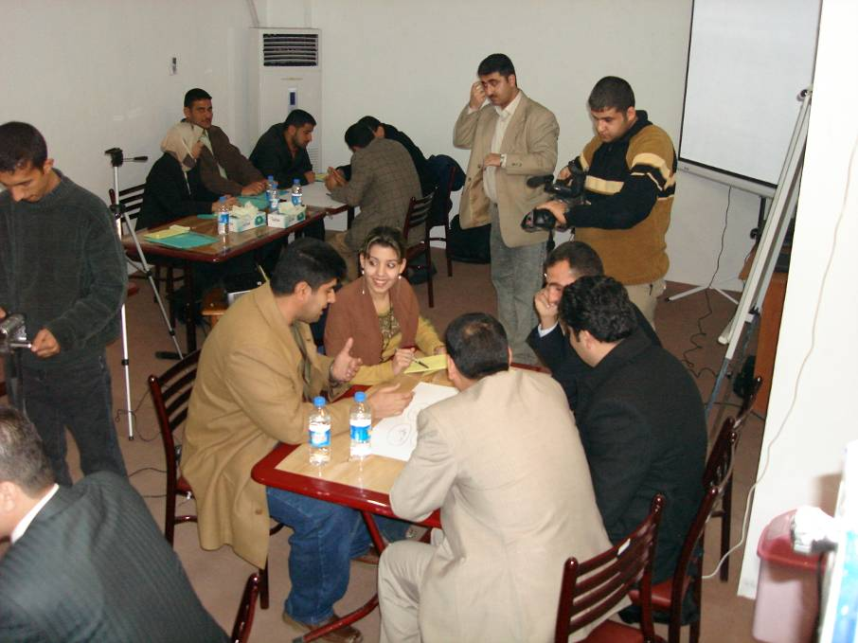

The outcome of this work was a combination of different local and international parties which enrich this conflict and complicate calming it.

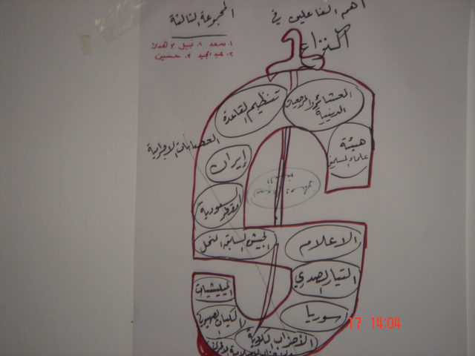

4.4.2: Non-violence definition & planning a non-violent work campaign
Ismaeel Dawood from UPP facilitated this session depending on brainstorming methodology; as the participants discussed several terms presented on the board, tried to define and differentiate between them. In addition, a discussion was held to present the most popular terms which are used in a wrong way such as non-violence: non-violence doesn't mean to stop the violence or violence doesn't equal power, but non-violence can be divided into two types: ethical and regular non-violence, at the same time, UPP stressed the point that non-violence is not sufficient only for certain conflicts but it proved its efficiency in several experiences : when combating dictatorship, occupation, political socio-cultural changes world wide and whatever the ruling system was.
The facilitator presented several examples from the history which Jean Sharp discussed in his book about the ''alternatives''. A handout was distributed among the participants to read: ''Non-violence, human energy to change, Civil Society's publications, Lebanon'', in addition to another exercise to remind of different historical events that Iraq passed through concerning certain terms (power, resistance, non-violence, violence, passive, occupation). The purpose of this exercise was to distinguish between passivism and non-violence, power and violence, and violence and non-violence resistance.

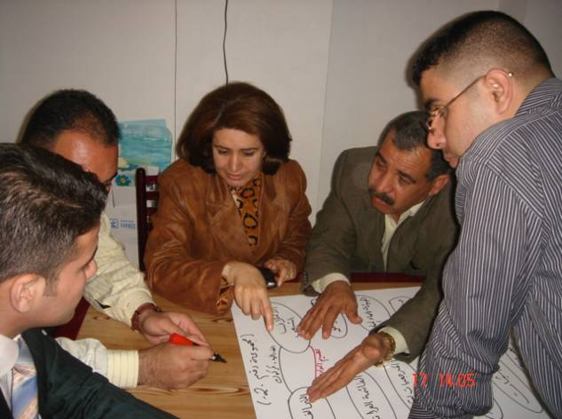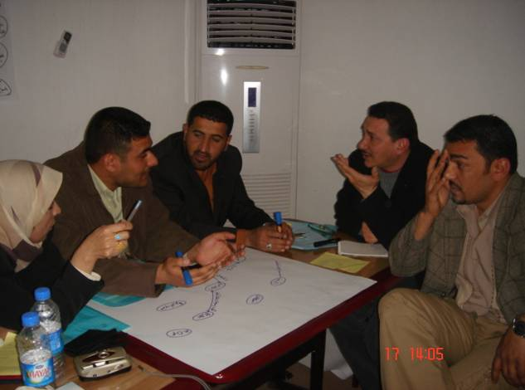

4-4-3: Strategic planning for Non-violence campaign:
The purpose of this session is to present the main steps suggested by Prof. Jean Marie Moller in his writings about planning a non-violent work campaign. The methodology was a sort of interaction between UPP, the presenter, and the participants. The discussion strategy was through presenting a certain step supporting it with historical examples. The planning starts by analysis, setting a goal (which should be realistic and achievable), and the non-violence choice should be, from a strategic point of view, not hidden, well organized and able to attract public opinion. Moreover, the non-violence choice should adopt a building program and maintain the relations with the opposite party in the conflict in all stages (starting and advanced stages). In addition, the necessity of counting oppression and proper preparedness to it –as it will be an essential part when planning and preparing.
A handout was distributed to the participants of Jean Marie Moller's article about stages of planning a non-violence campaign, in addition to an exercise of planning a campaign according to the Iraqi context.

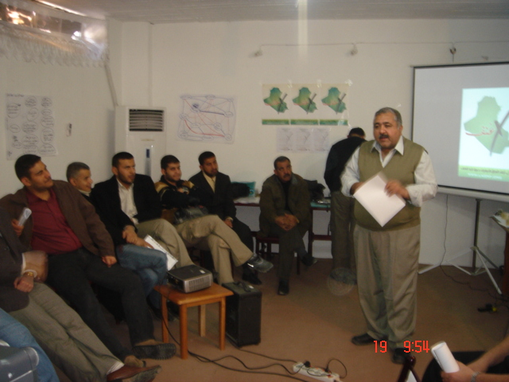

4.4.4: Experiences of peace building and non-violence from the participants

The used methodology was of direct interaction between the facilitator, who presented the initial idea, and the participants. The next session was for presenting each experience, defining it, integrating its each strengths and weaknesses, and suggesting ideas to improve it –all the experiences and examples were from the participants themselves.
The LAONF First Week Group presented a play before of presenting their experiences. The play was showing the different conflict parties in Iraq who represent sectarian and political fragmentations, and their tendency to blame each other but not to bear their responsibilities, which leaded Iraq to this mass stage of violence. After presenting the play, the group displayed the role of each activist of them, the coordination between members, and the main challenges and obstacles which face them.
LARSA centre presented their experiences of promoting for non-violence; through the conducted workshops that they organized in Baghdad. Similarly, the Students' Union of Najaf presented their experience of strikes and demonstration campaigns conducted to the sake of their colleagues who experienced arbitrary detention and beaten in the incident of the American troops' intrusion to Students' accommodations.
In addition, Peace Building Campaign/ Kurdistan presented the experience of violence within the period of 1994-1998. The riot in that period was caused by the main leading parties which had internal conflicts. The experience presented was through painting galleries which had a great participation of Kurdish artists. The exhibition place was in the separating area between the two parties to attract the attention of them. In the same area, some students' unions also gathered and demonstrated in an indication to the call of ending the conflict. Many other activities were conducted in the same area; recently, this area is called Beirer which symbolizes peace.
The participants were invited to visit Beirer location; to see what is left from Ismaeel Al-Khayyat's artistically made. The field visit motivated the members to think of the Art as a tool to expression and awareness among the public.

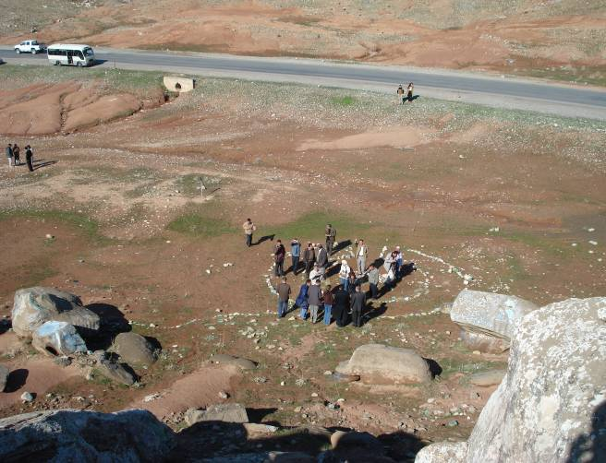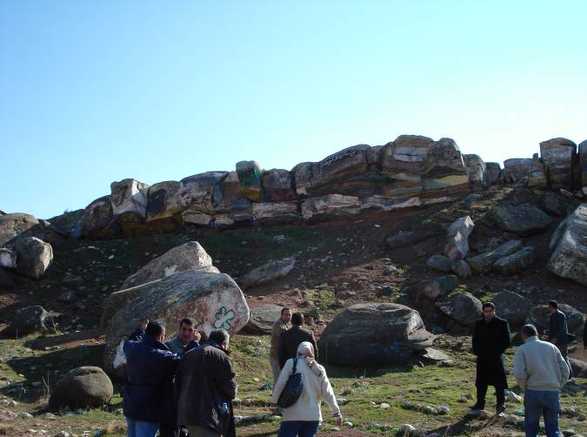

4.4.5: Recommendations & lessons' learned of the participants' experiences:
The session is designed just to summarize and classify the presented experiences, as some of them were:
- Peace building
- Promoting for non-violence (not only condemnation, but also presenting alternatives)
- Non-violence campaigns

This affected the trend of the participants' thinking towards more specialized type of activities, in accordance to the geographical areas, responding to the main three issues: non-violent work campaign, promotion of non-violence culture, and peace building campaigns.
The trainer presented the idea of a one week campaign, suggested that each group to select a time in accordance to the suitness of their geographical circumstances. At the same time, each group will present their forthcoming activities.

Groups' results:
- prioritizing peace building issue
- special attention to students whether in schools or universities
- more attention to promoting the non-violent alternative as a resistance tool (there was a confusion between defining the two terms of ''stopping violence'' and ''organized non-violence'')
- flexibility of conducting activities in accordance to the contextual needs, at the same time, to maintain the main common frame among all groups
- to conduct symbolic activities such as olive trees' planting, white balloons flying, white doves' flying, burying bullets, distributing posters about non-violence
- flexibility of changing the poster in accordance to the geographical need
- to promote for the non-violence culture in different activities conducted by all NGOs, and to be specialized for promoting for the coming week of non-violence
- to hold sessions/ forums about non-violence accompanied with printed publications
- to promote for calling to legislate special law to prevent from importing toys of kids which resemble guns and aggressive games.
- To conduct the week of non-violence within the period of May 2007, so it will proceed the students' examination time, but within school working days.
- Creation of a special website to assist these NGOs by the needed materials and well designed planned

4.4.6 Website session:
The main discussed website was (www.laonf.org), the discussion was about the development of this idea:
- adoption of a more opened policy; through connecting this website with other specialized links
- designing two formats for applications of joining for members and receiving newsletters for NGOs
- displaying members' logos with more details about their NGOs and their activities, at the same time, connecting the website with their homepages
- maintaining the specialization of the website about non-violence, but making it more attractive

- Workshop Evaluation

Daily evaluation was conducted through direct interaction with the participants, however, a special form was distributed to measure the participants' evaluation, and the results are as of the followings:
95% considered the opening session/ ice breaking was very good
80% considered the conflict analysis was very good
75% considered the used exercises for conflict analysis and defining conflict parties' session was very good
79% considered the non-violence definition session was very good
95% considered the session of strategic planning was very good
70% considered the website and newsletter session was very good
87% considered the non-violence week campaign session was very good
95% considered the session of planning for non-violence promotion activities is very good
94% considered the session of future plan is very good

- Constraints occurred during implementing the workshop

Some technical difficulties occurred pre/during the workshop implementation, such as the colleagues of NOVA couldn't attend, similarly the trainer from a Lebanese NGO couldn't travel from Lebanon to Erbil, which caused a change to the plans and made the organizers re-divide their roles and changing the materials in the last moment.
One of the participants from Falluja got sick, which made some of his colleagues join him in the hospital, where it occurred that he needs an urgent surgery. He spent all of training period in the hospital.
The main recommendation to face such constraints is to plan in a flexible way which helps to face such sudden changes.

7-Future plans for the week of non-violence in Iraq:

The selected date for this week is the 1st of May till the 6th. An invitation will be distributed among the members to join the week of non-violence with coordination between them in their geographical areas. Each group will implement some activities in accordance to their geographical areas in accordance to their needs and capability/ fund, these activities should be meeting the main goal of promoting for peace building and non-violence as a tool to change.

Almesalla Center in Baghdad and In Erbil will play the coordinating part in Iraq, and will keep the contact to support with the international partners especially NOVA, UPP, Centro Gandhi, the event both financially and technically and will insure that the news- information’s about this event will speared in all over the world

The main common activities between all groups are:

- planting olive trees in educational institutes such as schools/ universities and also in the house of parliament
- lightening candles in schools and universities
- flying white balloons also in schools and universities
- posters and leaflets' distribution promoting for non-violence culture
- t-shirts and hats distribution which carry the symbol of non-violence
- publications of articles about the ideology of non-violence and the alternative ways of resistance
- create an electronic account to provide consultancy when planning such campaigns and to respond to the members' needs

Written in Amman
UPP office
26- February 2007

